Abnormal Behavior Detection of Drivers in Vehicles

Dias N.E.K.A.S
Department of Electrical & Electronic Engineering
Faculty of Engineering, University of Jaffna
Kilinochchi, Sri Lanka
dias.kavindu5@gmail.com

Fernando W.S.D
Department of Electrical & Electronic Engineering
Faculty of Engineering, University of Jaffna
Kilinochchi, Sri Lanka
wsherman1993@gmail.com

Maduranga H.B.A.D
Department of Electrical & Electronic Engineering
Faculty of Engineering, University of Jaffna
Kilinochchi, Sri Lanka
darshanamadur@gmail.com

Abstract—Driver impairment due to drowsiness is known to be a major contributing factor in vehicle accidents. More than 30% of the road accidents are caused due to drowsiness condition of the driver. At present, there are various drowsiness detection systems available in the market. These systems are implemented using various implementation techniques such as detection of any behavioral pattern, changes in physiological conditions, or vehicular motion. Consequently, the accuracy of such systems has been found to be moderate. In here, we consider only the eye region which affects the drowsiness condition badly in order to achieve more accurate results. The purpose of this system is to reliably quantify commercial motor vehicle driver drowsiness and provide a real-time warning to the driver. The measure which we used is the eye closure duration. The system has been implemented by means of a camera, a Raspberry pi board and corresponding alarm system. Nearly 20000 images were used to train the system to obtain accurate results.
Keywords—Classifier, Drowsiness, OpenCV, Raspberry Pi,

Introduction
Accidents can be influenced according to three means, (1) human, (2) vehicular, and (3) surrounding factor. Nearly driver's error represented 91% of the accidents. The other two means of causative elements were referred to as 4% for the type of vehicle used and 5% for surrounding factors respectively. As a result drivers’ action takes a majority in accidents.
The attention level of driver degrade because of less sleep, long continuous driving or any other medical condition like brain disorders etc. Several surveys on road accidents says that around 30 percent of accidents are caused by drowsiness of the driver. When driver drives for more than normal period for human then excessive drowsy is caused and also results in tiredness which drives the driver to sleepy condition or loss of consciousness.
Drowsiness is a complex phenomenon which states that there is a decrease in alerts and conscious levels of the driver [10]. It might be caused by an absence of rest, medicine, substance misuse, or a cerebral issue. A driver who falls asleep is in an edge of losing control over the vehicle prompting crash with other vehicle or stationary bodies. Keeping in mind to stop or reduce the number of accidents to a great extent the condition of sleepiness of the driver should be observed continuously.
Though there is no direct measure to detect the drowsiness but several indirect methods can be used for this purpose. Research has shown that there are basically three ways to determine drowsiness in a driver: vehicle-based measures, behavioral patterns, and physiological measures [1], [2].
Volkswagen has developed a driver fatigue detection system, which can automatically monitor an operator’s driving characteristics [3]. Basically, the system will recommend that the driver take a break if it detects possible fatigue. This system is configured to continually evaluate driver’s fatigue based on various factors such as driving speed, steering wheel movement, the driver’s head position, and the driver’s eyes. Though many eye detection methods have been developed in the last decade, many problems remain due to facial expression, face orientation, occlusion and lighting conditions, which all can undoubtedly affect the performance of eye detection algorithm [9].
This paper puts forward a system that attempts to reach behavior of the eye to detect drowsiness in the driver since the eye is a main factor influenced in drowsiness to improve the accuracy. The system has been implemented using the input from a camera that is to be fixed in the car, in front of the driver. The camera records the face of the driver and the eye region is extracted for the detection of drowsiness. Whenever the user closes his/her eyelids for more than a predefined period of time, the alert goes off. This is detected by comparing and matching the images used in the training phase of the system with the real time images captured by the camera. The comparison and matching is done after each frame, and the user is given an alert upon detection of closed eyelids in a certain number of continuous frames.
The next sections of the paper discuss technical details of the project such as the hardware used, various technologies used to implement the system, etc. It then goes on to explain the implementation details of the prototype system which has been executed by means of the Raspberry pi board.

Background

Overview
The main concept of Driver Drowsiness Detection is to capture a driver’s face from a camera and extract the eye region that could be able to accurately calculate the level of drowsiness in drivers with real-time processing. To achieve these requirements, proper materials have to be selected. For the base computer, we selected Raspberry Pi 3 Model B. A USB camera was the visual device of choice. Moreover, hardware works great with well-designed software (Python). As such, software is the most important part in any designed device. For video and image processing, we chose OpenCV library for its completeness and convenience.

OpenCV
OpenCV (Open Source Computer Vision) is a cross-platform library of programming functions mainly aimed at real-time computer vision. It is free to use, and provides an array of functions for machine learning, neural networks, and other applications of artificial intelligence. To support machine learning, OpenCV provides a statistical machine learning library that contains boosting, decision tree learning, Artificial Neural Networks (ANN), Support Vector Machine (SVM), ensemble learning, etc. The OpenCV library provides a great number of functions for face detection, feature detection such as eyes, mouth, sunglasses, etc.

Cascade Classifier
The cascade classifier is a part of ensemble learning, which is implemented in various stages that consists of simpler classifiers. These are applied to a region of interest until input is accepted or rejected.

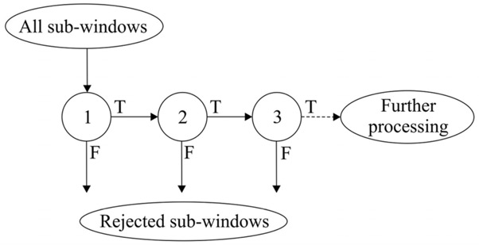
Figure 1 Cascade Classifier

First, a classifier is trained using a few hundred sample views of a particular object (i.e., a face or eyes according to this case), called positive samples, and negative samples, which are arbitrary images. Every positive and negative sample is scaled to the same size [6].
After a classifier is trained, it can be applied to a region of interest in an input image. This region should be of the same size as the samples used during the training. The output of the classifier will be “1” if the region is likely to show the object that we are looking for (i.e., faces/eyes), and “0” otherwise. It is also possible to search for the object in the whole image by moving the search window over the image and checking every location using the classifier.

Haar-Cascade Classifier
OpenCV provides programs (or functions) that are used to train classifiers for their face detection system, called HaarTraining [4]. We can create our own object classifiers using these functions. Also we used Cascade Trainer GUI software for HaarTraining, which is also base on python as well.


Figure 2 Haar-like features [7]

Object Detection using Haar feature-based cascade classifiers is a machine learning based approach where a cascade function is trained from a lot of positive and negative images. It is then used to detect objects in other images.
The algorithm extracts images using a lot of positive (faces, eyes, etc.) and negative images (arbitrary images without faces). Each feature is a single value obtained by subtracting sum of pixels under various regions of the images. Features include edge features, line features, etc. For each feature, the pixels used for extraction differs. Now all possible sizes and locations of each image kernel are used to calculate plenty of features. But all the features extracted will not be useful for the purpose at hand. For example, in this paper only eyes are relevant. Other facial features like cheeks, nose, mouth, ears, forehead, etc. are useless as far this paper is concerned. For this, we apply each and every feature on all the training images. For each feature, it finds the best threshold which will classify the faces to positive and negative. Initially each feature is given an equal weight. As the process continues, the weights are updated according to the results obtained so that accuracy is improved. The process is repeated until the required level of accuracy or the required number of features is found.
In an image, most of the image region is non-face region. So it is a better idea to have a simple method to check if a window is not a face region. If it is not, discard it in a single shot. Don't process it again. Instead focus on region where there can be a face [5]. This way, we can find more time to check a possible face region. For this they introduced the concept of Cascade of Classifiers. Instead of applying all the features on a window, group the features into different stages of classifiers and apply one-by-one. (Normally first few stages will contain very less number of features). If a window fails the first stage, discard it. We don't consider remaining features on it. If it passes, apply the second stage of features and continue the process. The window which passes all stages is a face region. This is how face detection and other eye detection are done using haartraining by means of cascade classifiers. Using a 2 GHz computer, a Haar classifier cascade could detect human faces at a rate of at least five frames per second [8].

Raspberry Pi board
The Raspberry Pi is a low cost, small sized computer that plugs into a PC monitor or TV, and uses a standard keyboard and mouse. It is a little device that enables people of all ages to explore computing, and to learn how to program in languages like Scratch and Python. It is capable of everything that a normal desktop computer can do, from word-processing, and playing games, browsing the internet and playing high-definition video, to making spreadsheets, etc.
The Raspberry Pi has the ability to interact with the outside world, and has been used in a wide array of digital maker projects, from music machines and parent detectors to weather stations and tweeting birdhouses with infra-red cameras. It can is an effective tool to perform functions like digital signal processing, and image processing.

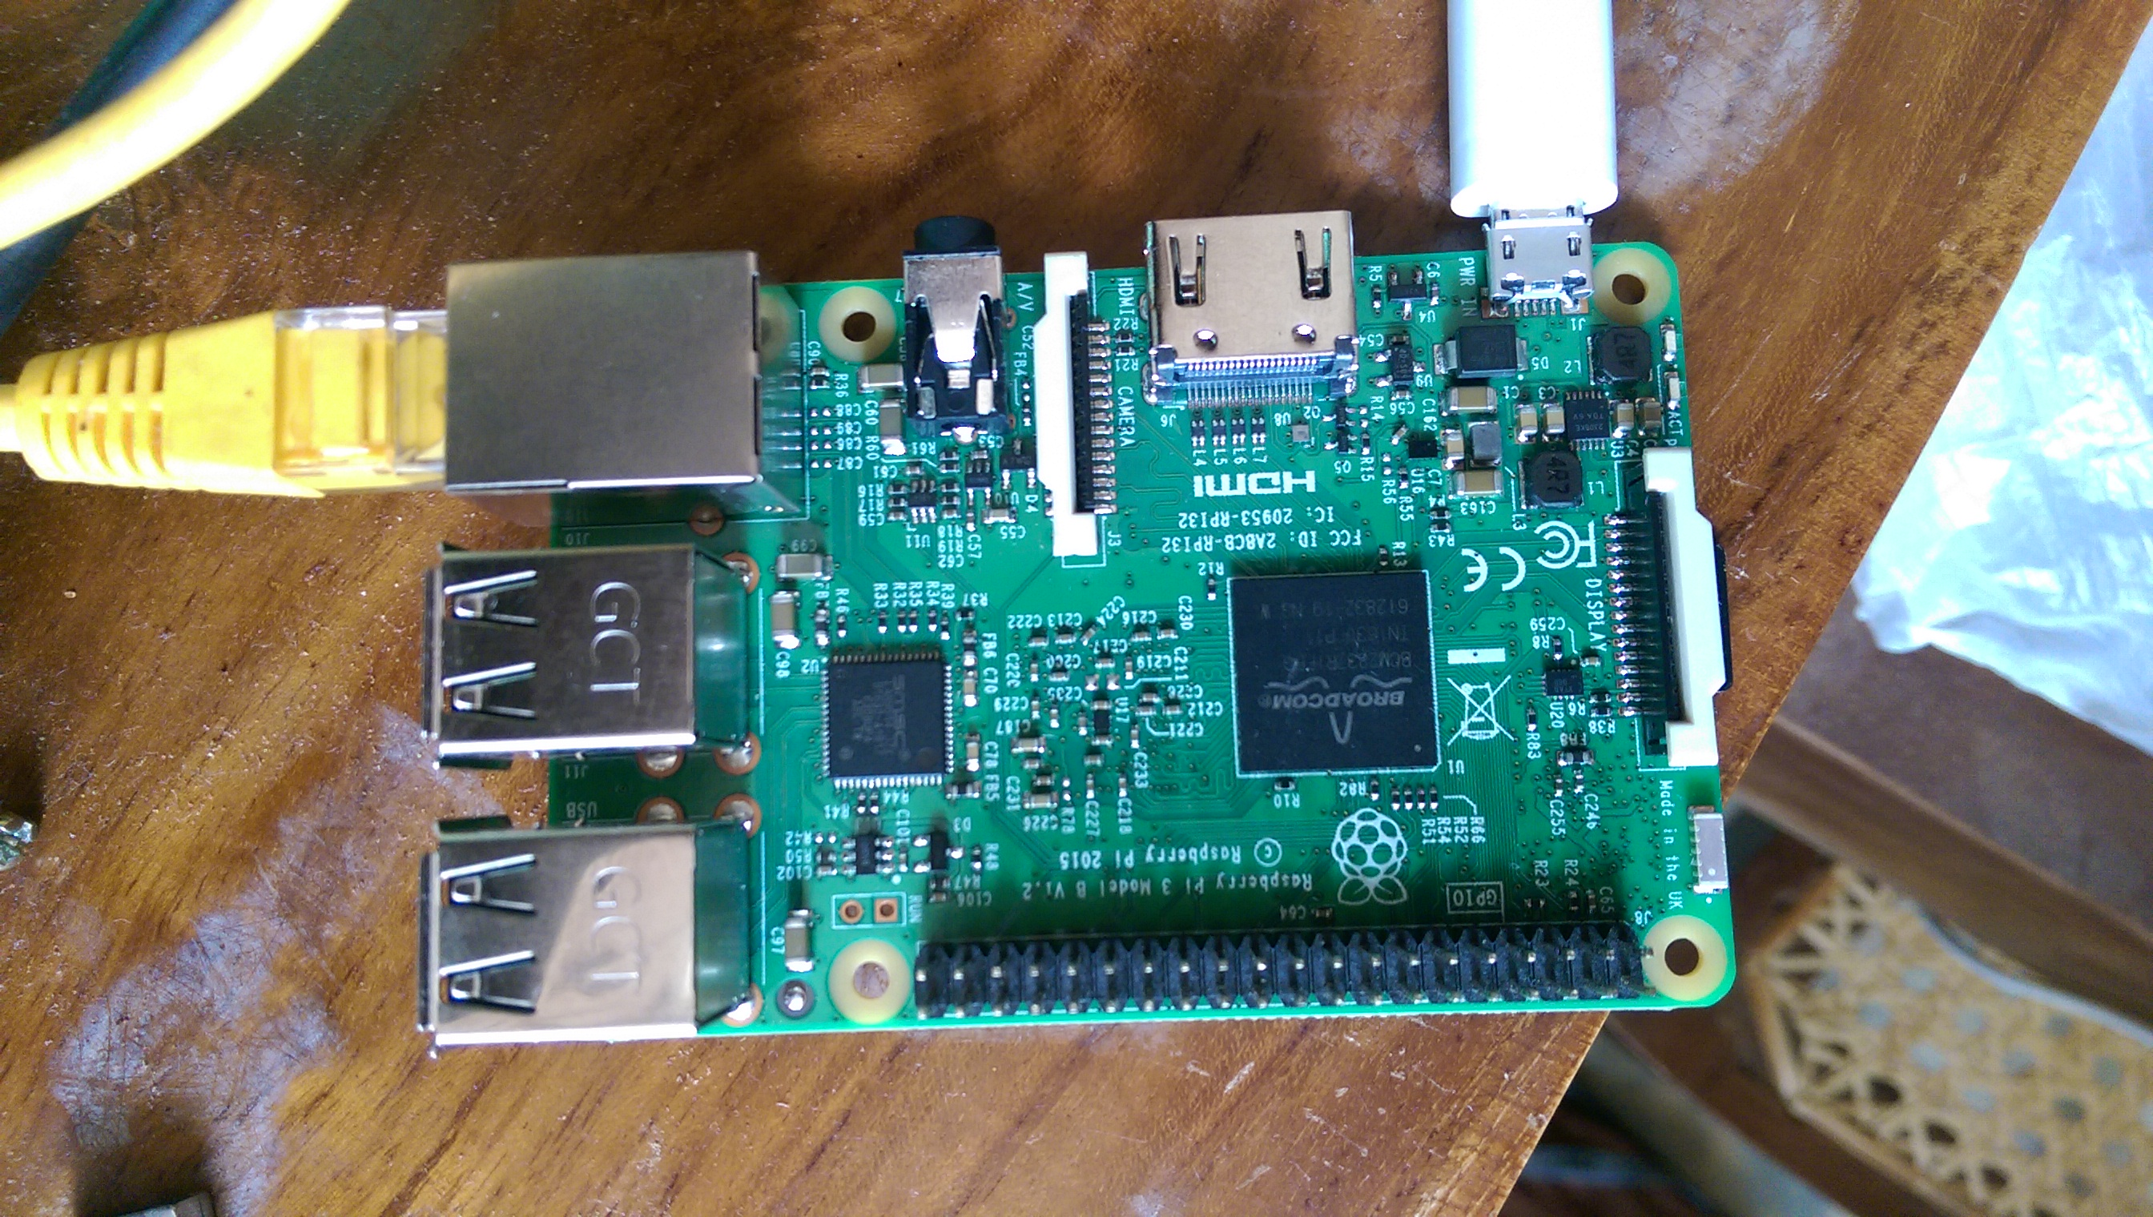
Figure 3 Raspberry Pi Model B

System Design
The system is designed as an independent unit, with a camera, a processor, and an alert system. The camera should support high definition capture for optimum performance. The video thus captured, is given as the input to the processor. The processor must be capable of image processing. The processor is connected to a buzzer which acts as an alert system. When required, the buzzer beeps, alerting the user to focus on the road or take a break to refresh.

Sample Collection
The system is almost entirely dependent on face detection, and eye detection. As a result we created a Dataset of our own. It includes 5 video clips (each 5min long) of a real driving scenario. The video clips were taken by placing a camera in front of bus route drivers with the help of their real situation of driving. As the ultimate task of doing the project is to improve the accuracy, we have considered three different light conditions as morning time, daytime and evening time. Out of five, two were taken on daytime and the rest on morning and evening with different drivers. Those video clips were divided into series of images around 20000 frames. This was to make the trained model more accurate with those lighting conditions. As the images contain real scenario incidents, all the related expressions from the faces were taken easily (close and open eye both). At the creation of trained model, a manual annotation was carried out for the face as well as for the eye with the attention of all positive samples. All the images of all three lighting conditions were subjected to be in one file and compared with negative images at the training. Thus we have taken 20000 samples as positive; nearly 40000 images were taken as negative samples in order to compare with the positive images (face images) at the training.

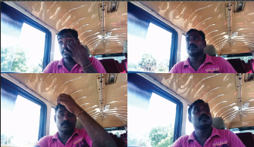
Figure 4 Positive Samples on Daytime

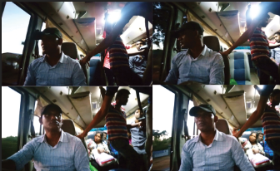
Figure 5 Positive samples on Night time

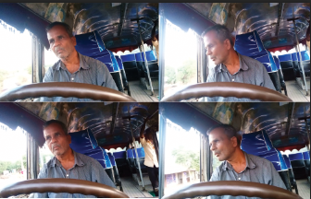
Figure 6 Positive samples on Morning time

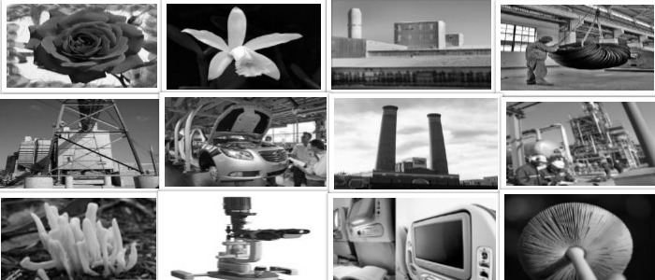
Figure 7 Negative Samples for the training

Cascade Training
Here, we used OpenCV_haartraining and Cascade Trainer GUI software to train a cascade classifier. This process may take a number of days depending on the number of samples and stages of the cascade classifier. But to be more accurate; number of samples and stages are used can be taken in higher values (ex: 25-50 stages can be selected for a quality model with high amount of positive and negative samples) though it consumes extra time. Once the application has finished execution, an XML file will be generated in the specified folder. The XML file is the final trained cascade classifier. According to the output two XML files were created for both face and eye. So when we test the trained cascade we were able to depict face detection as well as eye region detection.

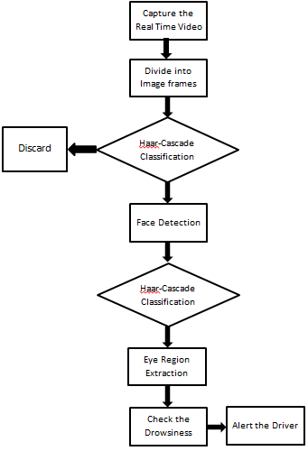

Face Detection
In this stage we detect the region containing the face of the driver. By face detection we means that locating the face in a frame or in other words finding location of facial characters with the help of the trained haar-cascade classifier. Paul Viola and Michael Jones invented this method. [5]

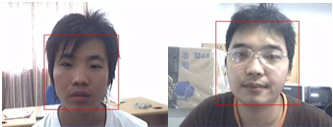
Figure 8 Face Detection

Images were tested with the Haar Cascade Classifier and Local binary pattern (LBP) classifier in order to get accuracy for the face detection, as shown in Figure 4. A percentage of face detection is about 86.11 percent based on the test cases in this study with the database used, as seen in Table I. This method works with both men and women. Even when the eyes are closed, detection of the face is still possible.
- Accuracy of face detection
Classification
Classification | Total No.of frames tested | Face Detected | Detected with errors
Haar-cascade | 225 | 196 | 29
LBP | 225 | 187 | 38

Eye Detection
After successful detection of face eye needs to be detected for further processing.
In our method eye is the decision parameter for finding the state of driver. So we use another haar cascade classifier which was trained for eye detection to detect the eye region of the driver. It was able to detect the eye even the person wear spectacles.

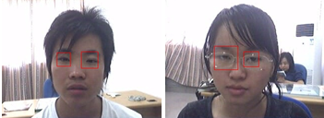
Figure 9 Eye Detection with and without spectacles

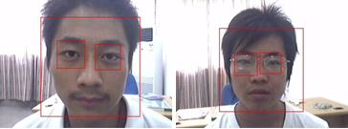
Figure 10 Face and Eye detection with and without spectacles

State of the Eye
For the detection of state of the eye, we trained only one model which follows the close eye. While the close eye is detected and classified by closed eye classifier, the state of the eye will automatically determine as close, and if the eye is detected in as open then the state of the eye is determined as open.

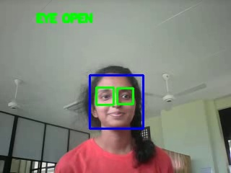
Figure 11 Detected opened eye

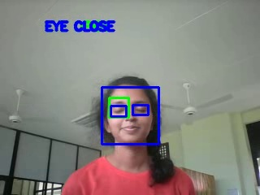
Figure 12 Detected closed eye

Drowsiness State of the eye
Normal eye blinking rate of a person has been found as 1/10th of sec. So if the person closes his/her eye for more than the blinking rate it can be a drowsy condition. In here we define an algorithm to capture the drowsiness of the eye. As the video is turned into series of images and each image is check one after the other, we can define if the consecutive frames found to be in close eye state and go beyond the given threshold frame number that is to be in drowsiness condition.

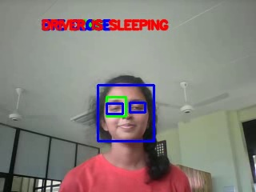
Figure 13 Detected Drowsiness condition

Conclusion

In this paper, a real-time eye state detection system using Haar Cascade Classifier has been presented. The detection of all face, eye region and closed eye was done by the help of trained models for each category. The results show that the accuracy of face detection is 91.2% using Haar-cascade classifier and 89.3% using LBP. As we used outdoor images for the training and for testing, it provides an fair accuracy on detecting the face.
In future works, a real-time drowsiness detection system for driving assistance will be developed with accurate models of driving states and it will be applied inside the vehicle.

Acknowledgment

Authors would like to thank the Department of Electrical and Electronic Engineering, Faculty of Engineering, University of Jaffna, Sri Lanka for supervising and supporting on this research project.

References
- S. Abdul-Kareem, Haitham Hasan. Static hand gesture recognition using neural networks. Springer Science+Business Media B.V. 2012
- Drowsy Driver Detection System, Neeta Parmar, Peter Hiscocks, Department of Electrical and Computer Engineering, Ryerson University
- Jan, T., Karnahl, Seifert, K., Hilgenstock, J., & Zobel, R. Don’t sleep and drive – VW’s fatigue detection technology. http://wwwnrd.nhtsa.dot.gov/pdf/esv/esv19/05-0037-O.pdf,2016
- OpenCV 2.4.12.0 documentation. Cascade Classifier Training, http://docs.opencv.org/2.4/doc/user_guide/ug_traincascade/; 2015, [Accessed 12-06-2018]
- Paul Viola, Michael Jones. Rapid Object Detection using a Boosted Cascade of Simple Features. Accepted conference on computer vision and pattern recognition; 2001
- Adolf, F. How-to build a cascade of boosted classifiers based on Haar-likefeatures.http://robotik.inflomatik.info/other/opencv/OpenCV_ObjectDetection_HowTo.pdf, June 20 2003.
- Open Computer Vision Library Reference Manual. Intel Corporation, USA, 2001.
- Lienhart, R. and Maydt, J. An extended set of Haar-like features for rapid object detection. IEEE ICIP 2002, Vol. 1, pp. 900-903, Sep. 2002..
- San, N. N. and Dr. Anye, N., “Face and Eye Detection Using Haar Cascade Classifier and Symmetry Detection”, International Journal of Information & Computer Science (IJITCS), 2014, 13.
- G. Pan, L. Sun, Z. Wu and S. Lao, “Eyeblink-based antispoofing in face recognition from a generic webcamera,” 2007 IEEE 11th International Conference on Computer Vision, pp. 1- 8, 2007.

